balenaFin v1.1 data sheet



The balenaFin is a carrier board for the Raspberry Pi Compute Module 3 Lite and Compute Module 3+ Lite[1] hardened for field deployment.

The balenaFin includes 8/16/32/64 GB of on-board industrial eMMC depending on the model, has dual-band connectivity for both 2.4 and 5GHz WiFi networks, can be connected to an external antenna for WiFi and Bluetooth, and can accept a wide range of DC power input via either the barrel jack or 2-position phoenix connector.

Low power mode and real time applications are supported through the integrated BGM111[2] microcontroller.

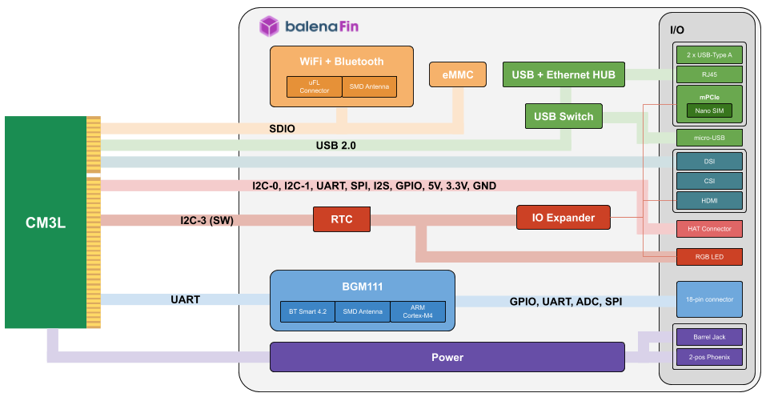

**Revision history** **2**

**Highlighted features list** **3**

**Availability and support** **4**

Ordering information 4

[WiP] Customization 4

**General specifications** **5**

**Pinout** **6**

Port mapping 6

HAT connector pinout (13) 8

**Co-processor connector pinout (25)** **8**

**How to use** **9**

**Mechanical Specifications (mm)** **10**

**Radio specifications** **11**

Frequency range 11

TX output power 11

RX sensitivity 11

**Certifications** **12**

# 

# Revision history

**V0.0.1**

* Date: 13/02/2019
* Author: Carlo María Curinga
* First draft

**V0.0.2**

* Date: 21/02/2019
* Author: Carlo María Curinga
* First release

**V0.0.3**

* Date: 22/02/2019
* Author: Carlo María Curinga
* Update temperature range lower value

**V0.0.4**

* Date: 06/06/2019
* Author: Nicolas Tzovanis
* Fixed HAT Header pinout for pin 13

**V0.0.5**

* Date: 24/06/2019
* Author: Nicolas Tzovanis
* Improved description of USB header

# Highlighted features list

Wireless Features

Radio Features

Software

* balenaOS
* Raspbian

Hardware interfaces

Electrical characteristics

Dimensions

# Availability and support

Availability of balenaFin in either the current version or a compatible later revision is guaranteed until at least January 2024.

## Ordering information

|  |  |
| --- | --- |
| **Part number** | **Description** |
| FIN0110-S08 | 8GB on-board eMMC |
| FIN0110-S16 | 16GB on-board eMMC |
| FIN0110-S32 | 32GB on-board eMMC |
| FIN0110-S64 | 64GB on-board eMMC |

## [WiP] Customization

Describe depop and conformal coating

# General specifications

|  |  |  |  |  |
| --- | --- | --- | --- | --- |
| **Parameter** | **Minimum** | **Typical** | **Maximum** | **Conditions** |
| Power input via power connectors | 6V | - | 24V | 12.5W |
| Power input via HAT connectors | 5V | 5V | 5V | 12.5W |
| Operation temperature | -25 celsius | - | +70 celsius |  |

# 

# Pinout

## Port mapping

**Top View**

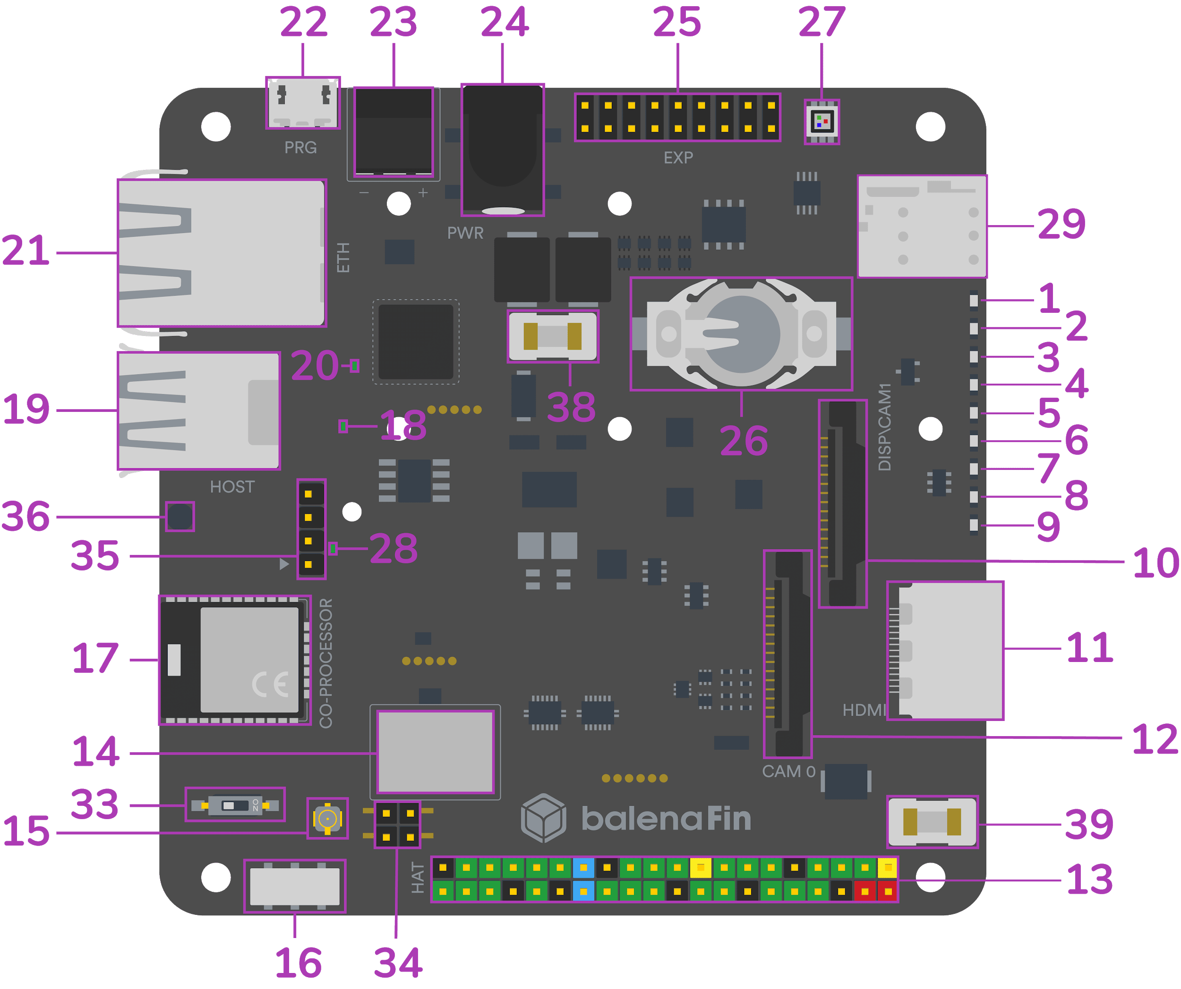

**Bottom View**

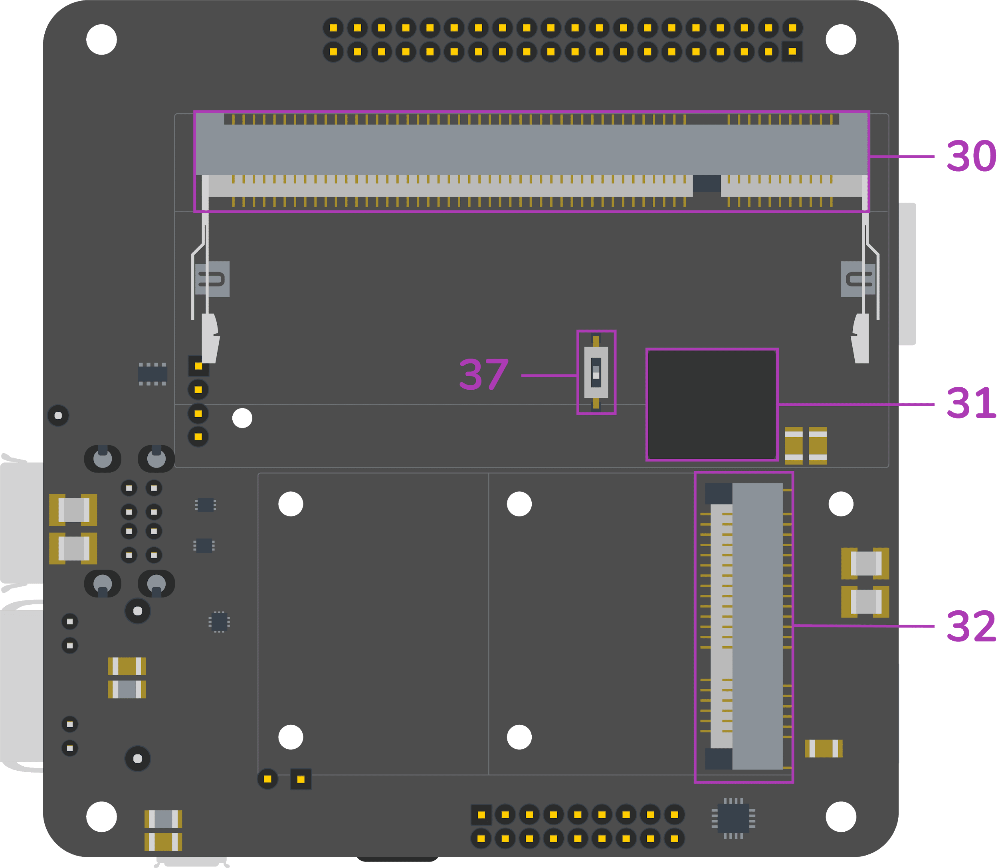

|  |  |  |
| --- | --- | --- |
| **#** | **Name** | **Description** |
| **Status LEDs** | | |
| 1 | 5V Status LED | Indicates 5V current flow |
| 2 | 3V3 Status LED | Indicates 3.3V available. Equivalent to the red LED on the RPi 3 Model B |
| 3 | ACT Status LED | CM3L activity LED. Equivalent to the red LED on the RPi 3 Model B |
| 4 | SPD Status LED | Ethernet Speed LED; off when in 10-Mbps mode, on when in 100-Mbps mode |
| 5 | FDX Status LED | Ethernet Full-Duplex indicator |
| 6 | LNK Status LED | Ethernet Link/Activity LED |
| 7 | PAN Status LED | Indicates PAN network activity on mPCIE card |
| 8 | LAN Status LED | Indicates LAN network activity on mPCIE card |
| 9 | WAN Status LED | Indicates WAN network activity on mPCIE card |
| **Graphic ports** | | |
| 10 | DSI/CSI connector | RPi MIPI connector. Configurable as secondary CSI via the DSI/CAM1 switch (37) |
| 11 | HDMI | Full-size HDMI Type A with CEC support |
| 12 | CSI connector | Standard full-size Raspberry Pi Camera (cam0) connector |
| 37 | DSI/CAM1 switch | Toggles DSI/CSI (10) connector between CSI and cam1 |
| **HAT** | | |
| 13 | HAT connector | 40-pin Raspberry Pi HAT (Hardware Attached on Top) standard connector |
| **Wifi/Bluetooth** | | |
| 14 | WiFi/BT combo chip | 802.11ac/a/b/g/n 2.4 & 5GHz WiFi + Bluetooth 4.2 |
| 15 | WiFi/BT uFL antenna connector | If the RF switch (33) is set on the external position, the antenna attached to this connector will become the main radio antenna for the WiFi/BT combo chip (14) |
| 16 | WiFi/BT SMD antenna | Embedded high-performance SMD antenna for 2.4 and 5GHz. |
| 33 | Antenna switch | Switches wireless module’s (14) internal (default) and external antenna. |
| **Co-processor** | | |
| 17 | Co- processor | Silicon Labs BGM111 MCU |
| 25 | Co- Processor I/O | 14-pin header exposing: 8 x GPIO / ADC, 1 x SPI, 1 x I2C, 1 x Debug UART |
| **USB** | | |
| 18 | USB1 Status LED | The green LED on when enough current flowing on the top USB port. |
| 19 | USB | 2 x USB Type-A |
| 20 | USB2 Status LED | The green LED on when enough current flowing on the top USB port. |
| 21 | Ethernet | 10/100 ethernet RJ45 connector |
| 22 | PRG | micro-USB connector that allows flashing of the eMMC from a host computer |
| 32 | mPCIe | Mini PCI Express socket |
| 29 | nano-SIM socket | Nano-SIM card slot connected to the mPCIe socket (32) |
| 35 | USB 2.0 4-pin header | Exposes a USB 2.0 port via male headers. Pin 1 is the one closest to the coprocessor. Pinout: 1->VCC; 2->D-; 3->D+; 4->GND |
| **Power** | | |
| 23 | Phoenix power in | Industry standard 2-POS Phoenix type connector for 6-24V input power |
| 24 | Barrel Jack power in | 2.1 / 5.5 mm barrel jack type connector for 6-24V input power. |
| 26 | RTC coin-cell socket | CR122 type coin-cell battery socket for RTC backup battery` |
| 34 | PoE HAT headers | Exposes PoE voltage from RJ45 (21) port for external PoE HATs. |
| 36 | GND probe interface | Exposes a GND probe interface for easy debugging |
| 38 | POWER IN Fuse | 3A 125VAC/VDC fuse - MPN: 0154003.DR. Applies to (23) and (24) |
| 39 | HAT 5V Fuse | 3A 125VAC/VDC fuse - MPN: 0154003.DR |
| **Raspberry Pi Compute Module** | | |
| 30 | CM3L socket | SODIMM-200 socket for the Raspberry Pi Compute Module 3/3+ Lite |
| 31 | eMMC | 8/16/32/64 GB class 5.1 industrial eMMC. Acts as main storage for the CM3L (30). |

### HAT connector pinout (13)

|  |  |  |  |  |  |  |
| --- | --- | --- | --- | --- | --- | --- |
| **Pin #** | **Name** | **Notes/Description** |  | **Pin #** | **Name** | **Notes/Description** |
| 1 | 3V3 | 3.3V rail, shared with CM |  | 2 | 5V | 5V rail, from regulator |
| 3 | I2C1_SDA | Compute Module I2C1 Data |  | 4 | 5V | 5V rail, from regulator |
| 5 | I2C1_SCL | Compute Module I2C1 Clock |  | 6 | GND | Ground |
| 7 | GPIO4 | Compute Module GPIO_4 |  | 8 | GPIO14 | Compute Module GPIO_14 |
| 9 | GND | Ground |  | 10 | GPIO15 | Compute Module GPIO_15 |
| 11 | GPIO17 | Compute Module GPIO_17 |  | 12 | GPIO18 | Compute Module GPIO_18 |
| 13 | GPIO27 | Compute Module GPIO_27 |  | 14 | GND | Ground |
| 15 | GPIO22 | Compute Module GPIO_22 |  | 16 | GPIO23 | Compute Module GPIO_23 |
| 17 | 3V3 | 3.3V rail, shared with CM |  | 18 | GPIO24 | Compute Module GPIO_24 |
| 19 | GPIO10 | Compute Module GPIO_10 |  | 20 | GND | Ground |
| 21 | GPIO9 | Compute Module GPIO_9 |  | 22 | GPIO25 | Compute Module GPIO_25 |
| 23 | GPIO11 | Compute Module GPIO_11 |  | 24 | GPIO8 | Compute Module GPIO_8 |
| 25 | GND | Ground |  | 26 | GPIO7 | Compute Module GPIO_7 |
| 27 | I2C0_SDA | Compute Module I2C0 Data |  | 28 | I2C0_SCL | Compute Module I2C0 Clock |
| 29 | GPIO5 | Compute Module GPIO_5 |  | 30 | GND | Ground |
| 31 | GPIO6 | Compute Module GPIO_6 |  | 32 | GPIO12 | Compute Module GPIO_12 |
| 33 | GPIO13 | Compute Module GPIO_13 |  | 34 | GND | Ground |
| 35 | GPIO19 | Compute Module GPIO_19 |  | 36 | GPIO16 | Compute Module GPIO_16 |
| 37 | GPIO26 | Compute Module GPIO_26 |  | 38 | GPIO20 | Compute Module GPIO_20 |
| 39 | GND | Ground |  | 40 | GPIO21 | Compute Module GPIO_21 |

### Co-processor connector pinout (25)

|  |  |  |  |  |  |  |
| --- | --- | --- | --- | --- | --- | --- |
| **Pin #** | **Name** | **Notes/Description** |  | **Pin #** | **Name** | **Notes/Description** |
| 1 | MCU_GPIO0 | Co-processor GPIO_0 |  | 2 | 3V3 | 3.3V rail, from regulator |
| 3 | MCU_GPIO1 | Co-processor GPIO_1 |  | 4 | SPI_MCU_CS-CON_EXT |  |
| 5 | MCU_GPIO2 | Co-processor GPIO_2 |  | 6 | SPI_MCU_CS-SCLK_EXT |  |
| 7 | MCU_GPIO3 | Co-processor GPIO_3 |  | 8 | SPI_MCU_CS-MOSI_EXT |  |
| 9 | MCU_GPIO4 | Co-processor GPIO_4 |  | 10 | SPI_MCU_CS-MISO_EXT |  |
| 11 | MCU_GPIO5 | Co-processor GPIO_5 |  | 12 | DBG_uP-RX_DEV-TX_EXT |  |
| 13 | MCU_GPIO6 | Co-processor GPIO_6 |  | 14 | DBG_uP-TX_DEV-RX_EXT |  |
| 15 | MCU_GPIO7 | Co-processor GPIO_7 |  | 16 | MCU_GPIO8 | Co-processor GPIO_8 |
| 17 | GND | Ground |  | 18 | MCU_GPIO9 | Co-processor GPIO_9 |

# 

# How to use

Switches the full-size Raspberry Pi MIPI connector (10) between Display or secondary Camera (cam1) mode - when set to OFF (labeled in silkscreen as "DISP"), the full-size Raspberry Pi MIPI connector (#10) exposes the DSI (disp1) interface. When set to ON (labeled in silkscreen as "CAM1") the full-size Raspberry Pi MIPI connector (10) exposes the secondary CSI (cam1) interface

2 position switch - when set to OFF (labeled in silkscreen as "INT"), the WiFi/BT combo chip (14) uses the WiFi/BT embedded antenna (16). When set to ON (labeled in silkscreen as "EXT"), the WiFi/BT combo chip (14) uses the WiFi/BT uFL antenna connector (15)

usingbalenaEtcher (balena.io/etcher)or usbboot. If the device is powered via a cable connected to this port, it will enter a programming mode exposing its eMMC as mass-storage to a host computer (via balenaEtcher or usbboot). balenaFin can only be booted into flash mode via this port

# Mechanical Specifications (mm)

**Top view**

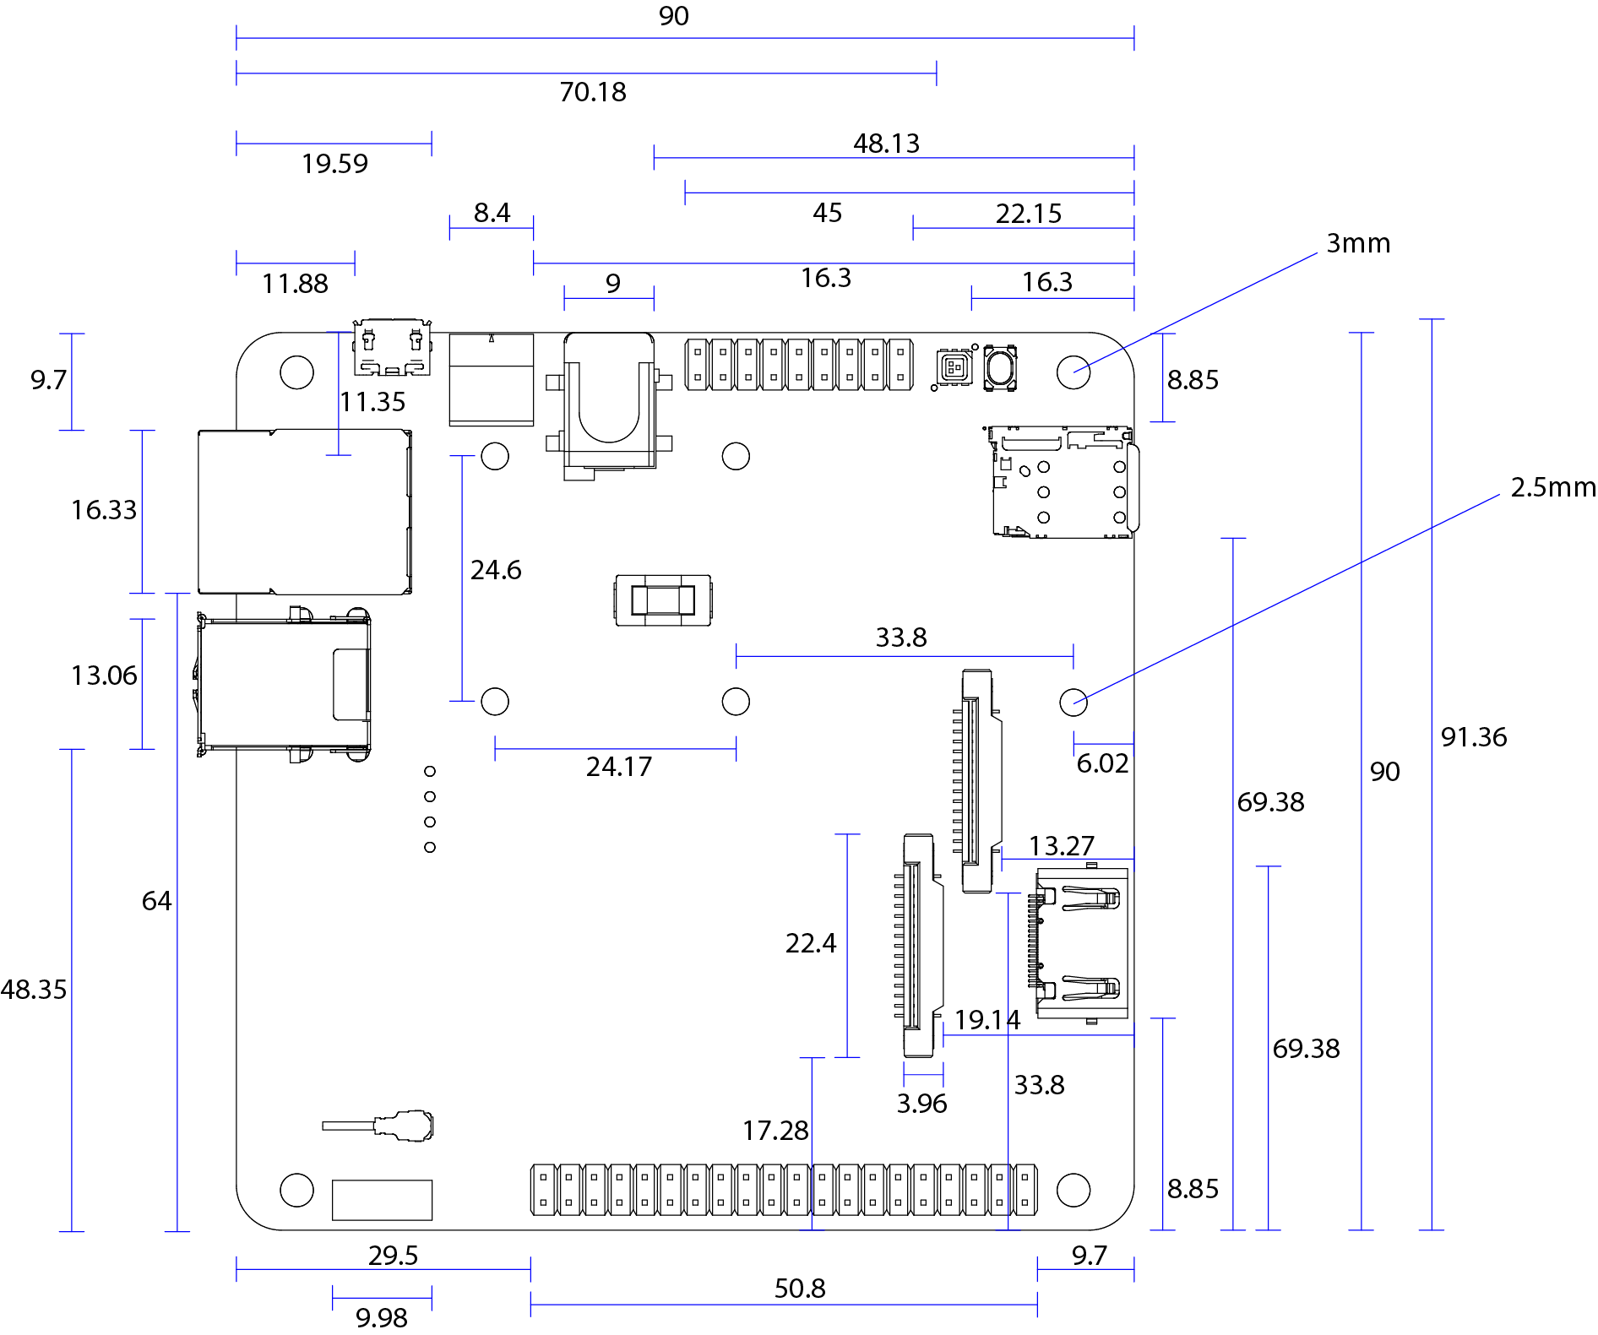

**Bottom view**

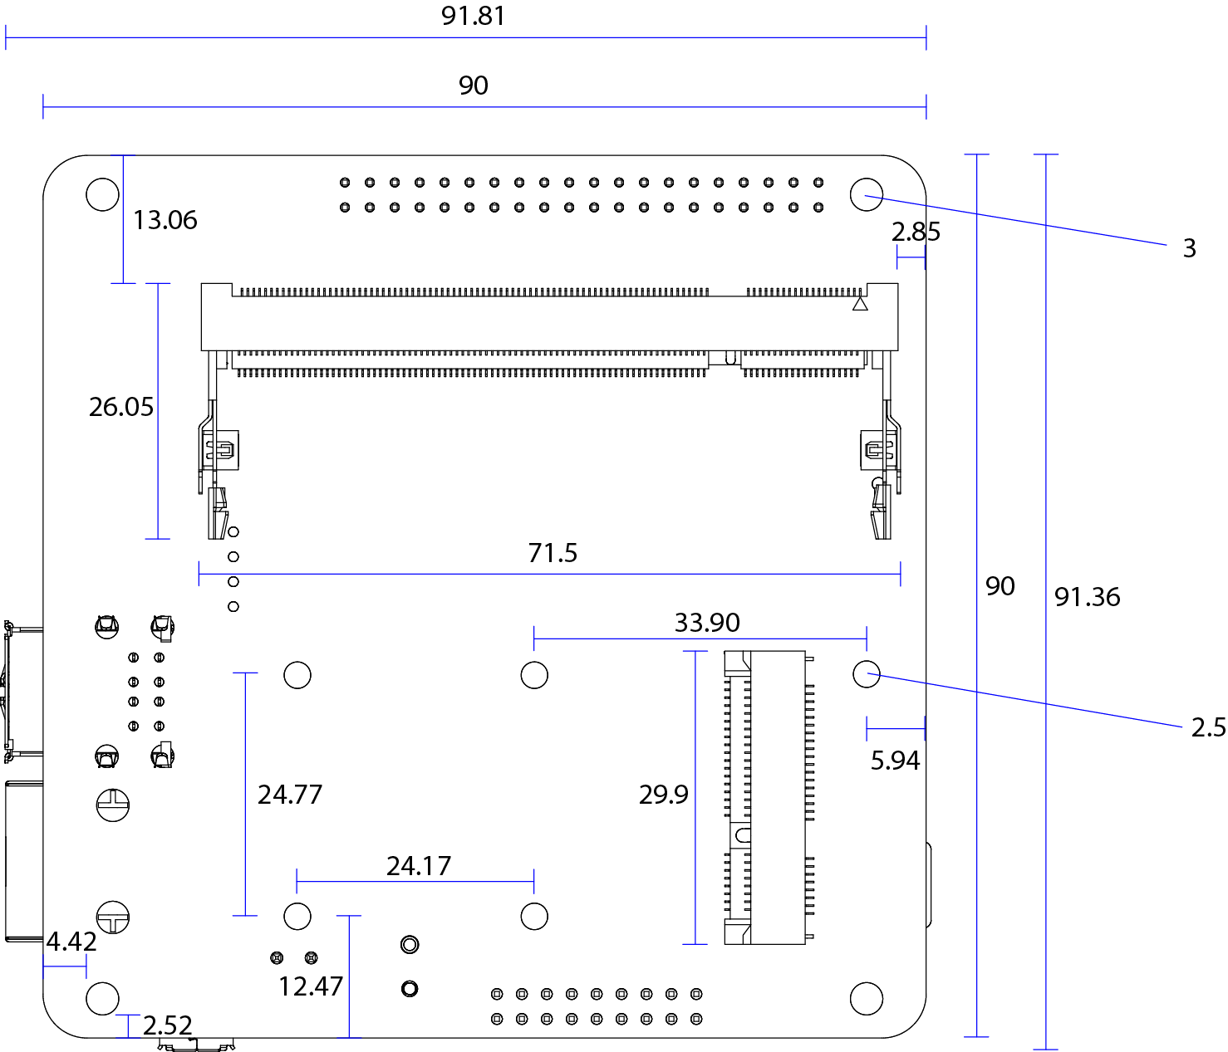

# Radio specifications

### Frequency range

|  |  |  |  |  |
| --- | --- | --- | --- | --- |
| **Description** | **Min.** | **Typ.** | **Max** | **Units** |
| 11b / 11g / 11n-2GHz (HT20) / 11n-2GHz (HT40) | 2412 | - | 2472 | MHz |
| 11a / 11n-5GHz (20TH) / 11n-5GHz (40TH) / 11ac | 5180 | - | 5825 | MHz |
| BT/BLE main | 2402 | - | 2480 | MHz |
| BLE secondary (co-processor) | 2400 | - | 2483.5 | MHz |

### TX output power

|  |  |  |  |  |
| --- | --- | --- | --- | --- |
| **Description** | **Min.** | **Typ.** | **Max** | **Units** |
| 11b / 11g / 11n-2GHz (HT20) / 11n-2GHz (HT40) | 10/10/10 | 12/12/12 | 14/14/14 | dBm |
| 11a / 11n-5GHz (20TH) / 11n-5GHz (40TH) / 11ac | 10/10/8/6 | 12/12/10/ 8 | 14/14/12/10 | dBm |
| BT/BLE main | -6 | 0 | 4 | dBm |
| BLE secondary (co-processor) | -26 | - | 8 | dBm |

### RX sensitivity

|  |  |  |  |  |
| --- | --- | --- | --- | --- |
| **Description** | **Min.** | **Typ.** | **Max** | **Units** |
| 11b / 11g / 11n-2GHz (HT20) / 11n-2GHz (HT40) | - | -78/-73/-69/-66 | -76/-65/-64/-61 | dBm |
| 11a / 11n-5GHz (20TH) / 11n-5GHz (40TH) / 11ac | - | -71/-68/-65/-57 | -65/-64/-61/-51 | dBm |
| BT/BLE main | - | -86/-86 | -70/-70 | dBm |
| BLE secondary (co-processor) | - | -55.2/-47.2 | - | dBm |

# Certifications

|  |  |  |
| --- | --- | --- |
| **Certification** | **Country / Region** | **Identifier(s)** |
| CE | Europe | RE-18071303 |
| FCC | USA | 2APW6BLN-FN-1-00001 |
| IC | Canada | 24038-BLNFN100001 |
| MIC | Japan | R-208-180131 |
| RCM | Australia | N/A |
| OFCA | Hong Kong | US0021800029 |

Laboratory test results and DoC available at [www.balena.io/fin](http://www.balena.io/fin)